# PFW_PrimaryEmail Updated: 1/29/2021

# How To Export Data from the Class Roster

## to an Excel Spreadsheet

1. To access class rosters you will need to go to Banner screen: SFASLST
   1. Once there you will need the term and CRN to pull up the class roster
   2. If you do not have the CRN, you can search for it by clicking on the ellipses in the CRN box. In the search you will need to put the term in and you can search by Subject and/or Course Number to find the CRN.
   3. Once you find the course you are looking for, you can click on the CRN and press Select, in the lower right-hand corner. Or, you can just double click on the CRN and the information will carry over.
2. Once you have the correct term and CRN, press Go.
3. With the class roster names displayed on your screen, click on TOOLS and select Export.

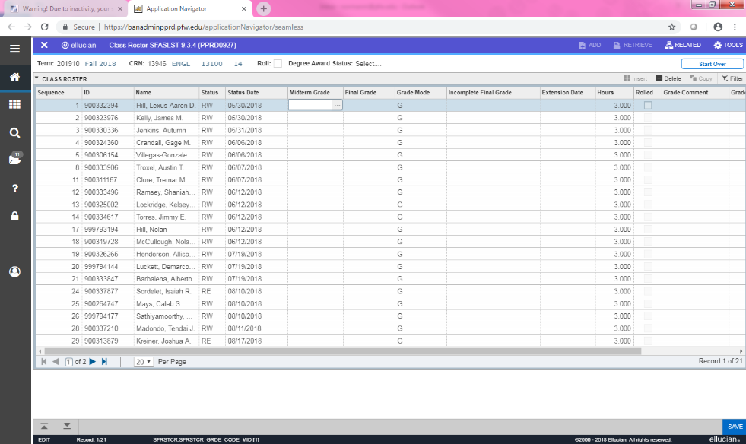

1. A tool bar will appear at the bottom of your screen. Click on the SFASLST.csv file.

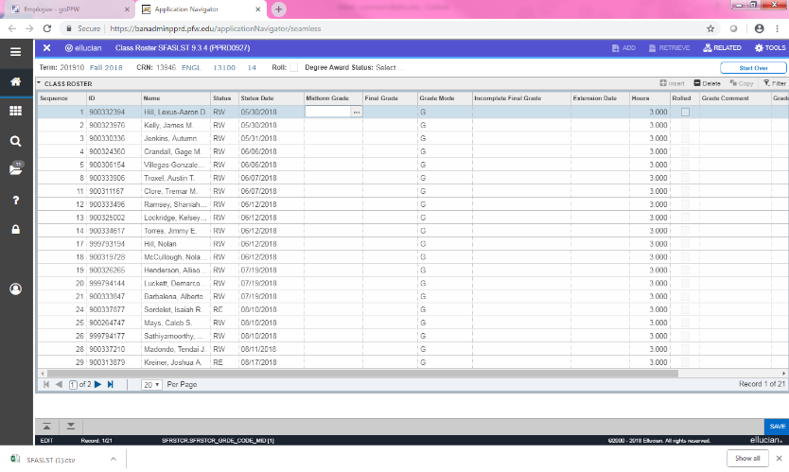

1. This will then open your class list in Excel. You may format the document however you’d like.

*Note: Data from Banner is not formatted correctly in Excel. Column headings do not come over. Also, to format the ID number correctly on the class roster, you may simply need to widen the column.*

1. Save As/Print as needed.